For ALL examples, remove the highlighted fields including the *** and add button text or process sid where applicable.
Example 1:
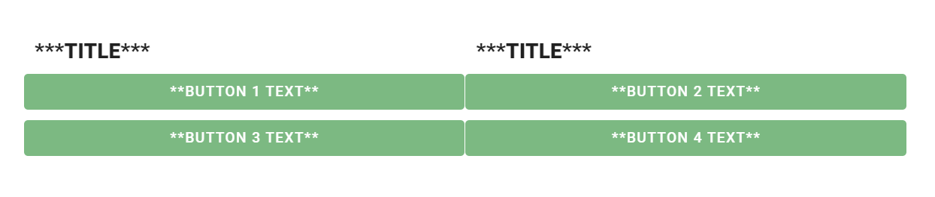
<p><br />&nbsp;</p>
<table border="25" cellpadding="0" cellspacing="0" style="border-collapse: collapse; width: 100%; border-color: #ffffff; border-style: solid; height: 112px;">
<tbody>
<tr style="height: 54px;">
<td style="width: 50%; height: 54px;">
<h2 style="border: 1px solid #FFFFFF; display: table-cell; padding: 10px 10px; background-color: white; text-align: center;"><strong>***TITLE***</strong></h2>
</td>
<td style="width: 50%; height: 54px;">
<h2 style="border: 1px solid #FFFFFF; display: table-cell; padding: 10px 10px; background-color: white; text-align: center;"><strong>***TITLE***</strong></h2>
</td>
</tr>
<tr style="height: 15px;">
<td style="width: 24.1096%; height: 24px;"><button class="v-btn v-btn--contained theme--light v-size--default secondary darken-2 v-btn v-btn--block v-btn--contained theme--light v-size--default" onclick="Integrify.startRequest({process_sid: '***PASTE SID***'})">**BUTTON 1 TEXT**</button></td>
<td style="width: 48.3396%; height: 24px;"><button class="v-btn v-btn--contained theme--light v-size--default secondary darken-2 v-btn v-btn--block v-btn--contained theme--light v-size--default" onclick="Integrify.startRequest({process_sid: '***PASTE SID***'})"> **BUTTON 2 TEXT** </button></td>
</tr>
<tr style="height: 10px;">
<td style="width: 24.1096%; height: 10px;"></td>
<td style="width: 48.3396%; height: 10px;"></td>
</tr>
<tr style="height: 24px;">
<td style="width: 24.1096%; height: 24px;"><button class="v-btn v-btn--contained theme--light v-size--default secondary darken-2 v-btn v-btn--block v-btn--contained theme--light v-size--default" onclick="Integrify.startRequest({process_sid: '***PASTE SID***'})">**BUTTON 3 TEXT** </button></td>
<td style="width: 48.3396%; height: 24px;"><button class="v-btn v-btn--contained theme--light v-size--default secondary darken-2 v-btn v-btn--block v-btn--contained theme--light v-size--default" onclick="Integrify.startRequest({process_sid: '***PASTE SID***'})"> **BUTTON 4 TEXT** </button></td>
</tr>
</tbody>
</table>

Example 2:
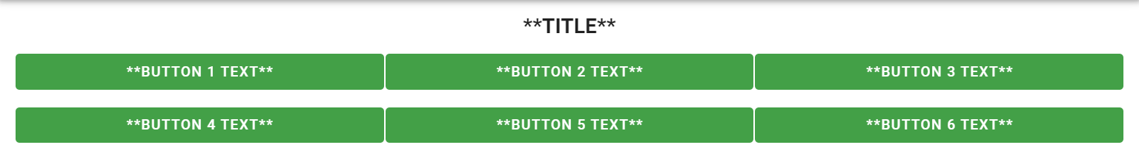
<h2 style="text-align: center;">**TITLE**</h2>
<p></p>
<table style="width: 100%; text-align: center;">
<tbody>
<tr style="text-align: center; border-style: none;">
<th style="border-style: none; width: 33%;">
<p><button class="v-btn v-btn--contained theme--light v-size--default primary v-btn v-btn--block v-btn--contained theme--light v-size--default" onclick="Integrify.startRequest({process_sid: '**Process SID***'})"> **BUTTON 1 TEXT** </button></p>
</th>
<th style="border-style: none; width: 33%;">
<p><button class="v-btn v-btn--contained theme--light v-size--default primary v-btn v-btn--block v-btn--contained theme--light v-size--default" onclick="Integrify.startRequest({process_sid: '**Process SID***'})"> **BUTTON 2 TEXT** </button></p>
</th>
<th style="width: 33%;">
<p><button class="v-btn v-btn--contained theme--light v-size--default primary v-btn v-btn--block v-btn--contained theme--light v-size--default" onclick="Integrify.startRequest({process_sid: '**Process SID***'})"> **BUTTON 3 TEXT** </button></p>
</th>
</tr>
<tr style="text-align: center;">
<th style="border-style: none; width: 33%;">
<p><button class="v-btn v-btn--contained theme--light v-size--default primary v-btn v-btn--block v-btn--contained theme--light v-size--default" onclick="Integrify.startRequest({process_sid: '**Process SID***'})"> **BUTTON 4 TEXT** </button></p>
</th>
<th style="border-style: none; width: 33%;">
<p><button class="v-btn v-btn--contained theme--light v-size--default primary v-btn v-btn--block v-btn--contained theme--light v-size--default" onclick="Integrify.startRequest({process_sid: '**Process SID***'})"> **BUTTON 5 TEXT** </button></p>
</th>
<th style="border-style: none; width: 33%;">
<p><button class="v-btn v-btn--contained theme--light v-size--default primary v-btn v-btn--block v-btn--contained theme--light v-size--default" onclick="Integrify.startRequest({process_sid: '**Process SID***'})"> **BUTTON 6 TEXT** </button></p>
</th>
</tr>
</tbody>
</table>

Example 3:
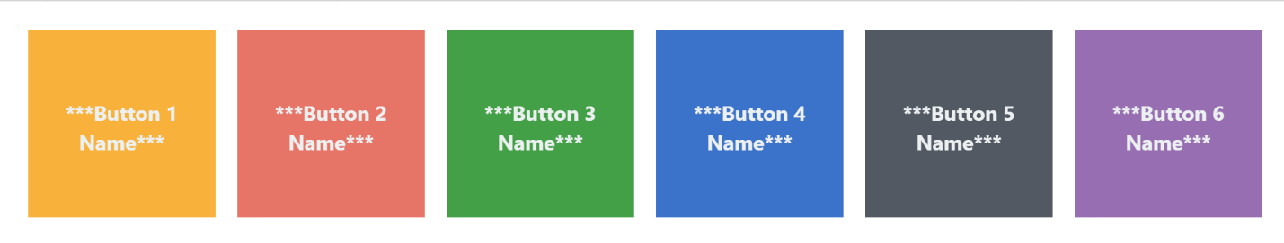
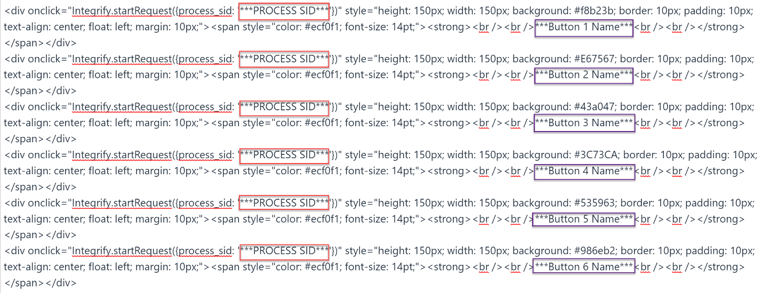
<div onclick="Integrify.startRequest({process_sid: '***PROCESS SID***'})" style="height: 150px; width: 150px; background: #f8b23b; border: 10px; padding: 10px; text-align: center; float: left; margin: 10px;"><span style="color: #ecf0f1; font-size: 14pt;"><strong><br /><br />***Button 1 Name***<br /><br /></strong></span></div>
<div onclick="Integrify.startRequest({process_sid: '***PROCESS SID***'})" style="height: 150px; width: 150px; background: #E67567; border: 10px; padding: 10px; text-align: center; float: left; margin: 10px;"><span style="color: #ecf0f1; font-size: 14pt;"><strong><br /><br />***Button 2 Name***<br /><br /></strong></span></div>
<div onclick="Integrify.startRequest({process_sid: '***PROCESS SID***'})" style="height: 150px; width: 150px; background: #43a047; border: 10px; padding: 10px; text-align: center; float: left; margin: 10px;"><span style="color: #ecf0f1; font-size: 14pt;"><strong><br /><br />***Button 3 Name***<br /><br /></strong></span></div>
<div onclick="Integrify.startRequest({process_sid: '***PROCESS SID***'})" style="height: 150px; width: 150px; background: #3C73CA; border: 10px; padding: 10px; text-align: center; float: left; margin: 10px;"><span style="color: #ecf0f1; font-size: 14pt;"><strong><br /><br />***Button 4 Name***<br /><br /></strong></span></div>
<div onclick="Integrify.startRequest({process_sid: '***PROCESS SID***'})" style="height: 150px; width: 150px; background: #535963; border: 10px; padding: 10px; text-align: center; float: left; margin: 10px;"><span style="color: #ecf0f1; font-size: 14pt;"><strong><br /><br />***Button 5 Name***<br /><br /></strong></span></div>
<div onclick="Integrify.startRequest({process_sid: '***PROCESS SID***'})" style="height: 150px; width: 150px; background: #986eb2; border: 10px; padding: 10px; text-align: center; float: left; margin: 10px;"><span style="color: #ecf0f1; font-size: 14pt;"><strong><br /><br />***Button 6 Name***<br /><br /></strong></span></div>

Contact Information Panel:
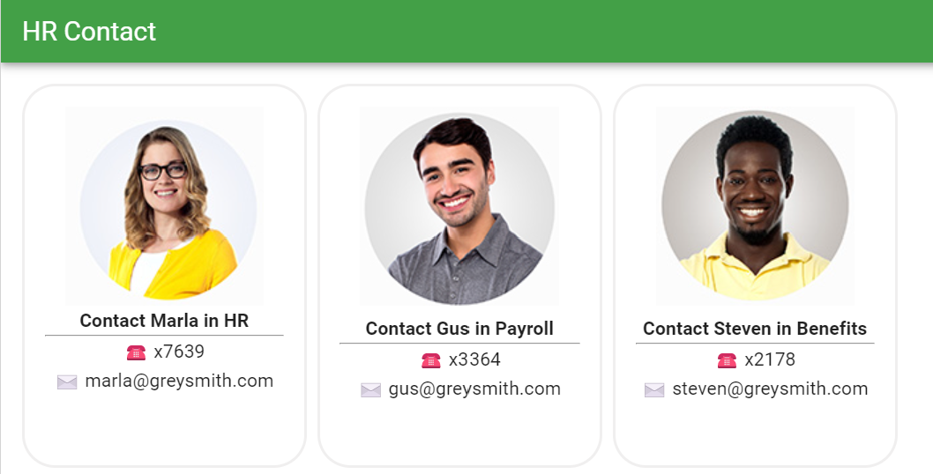
<div style="float: left; border-radius: 25px; padding: 15px; border-style: solid; border-color: #F0EFEF; width: 215px; height: 290px; text-align: center; margin-right: 8px;"><img src="blob:https://plus-salesdemo.integrify.com/7dcc5a2c-7599-4cce-9b84-98fc342e9abb" style="display: block; margin-left: auto; margin-right: auto;" /><strong>Contact Marla in HR</strong><br /><hr />☎️ x7639<br />✉️ marla@greysmith.com</div>
<div style="float: left; border-radius: 25px; padding: 15px; border-style: solid; border-color: #F0EFEF; width: 215px; height: 290px; text-align: center; margin-right: 8px;"><img src="blob:https://plus-salesdemo.integrify.com/1d0aad11-06c9-4903-a0b5-7a0e4553ccbe" /><br /><strong>Contact Gus in Payroll</strong><br /><hr />☎️ x3364<br />✉️ gus@greysmith.com</div>
<div style="float: left; border-radius: 25px; padding: 15px; border-style: solid; border-color: #F0EFEF; width: 215px; height: 290px; text-align: center;"><img src="blob:https://plus-salesdemo.integrify.com/38d8263c-30a2-4010-9a12-067db5df834f" /><br /><strong>Contact Steven in Benefits</strong><br /><hr />☎️ x2178<br />✉️ steven@greysmith.com</div>

Widget Example Websites:
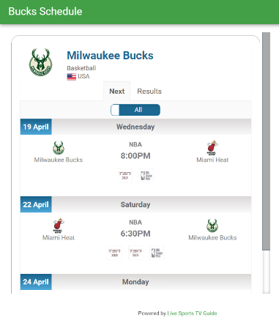

https://sport-tv-guide.live/

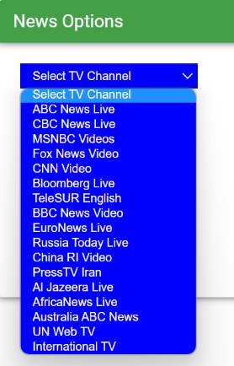

<p><iframe height="40px" name="tv" scrolling="no" src="https://newstodayintheworld.com/tv_iframe.htm" style="border: 0px;" width="230px"></iframe></p>

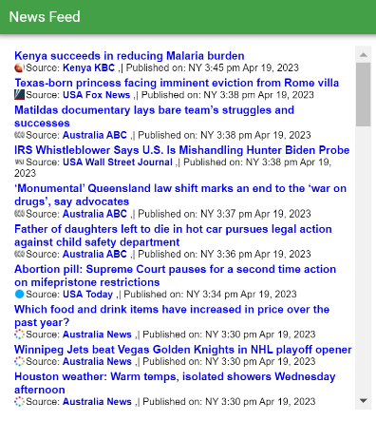

<p><iframe frameborder="0" height="500" marginheight="4" marginwidth="2" name="momentary_review" src="https://newstodayintheworld.com/widget/" style="background-color: #ffffff;" width="500"></iframe></p>

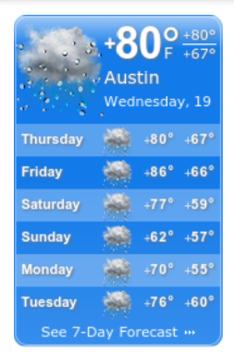
https://www.booked.net/?page=weather_widget_customize&type=4&cityid=607

